**NLP Basics for LLM**

**What is NLP?**

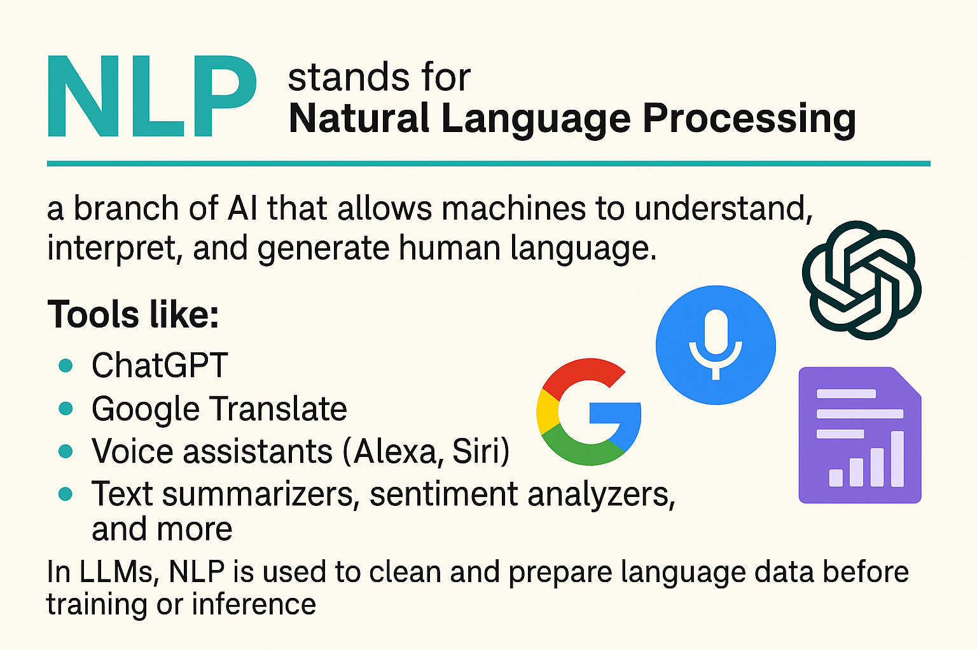

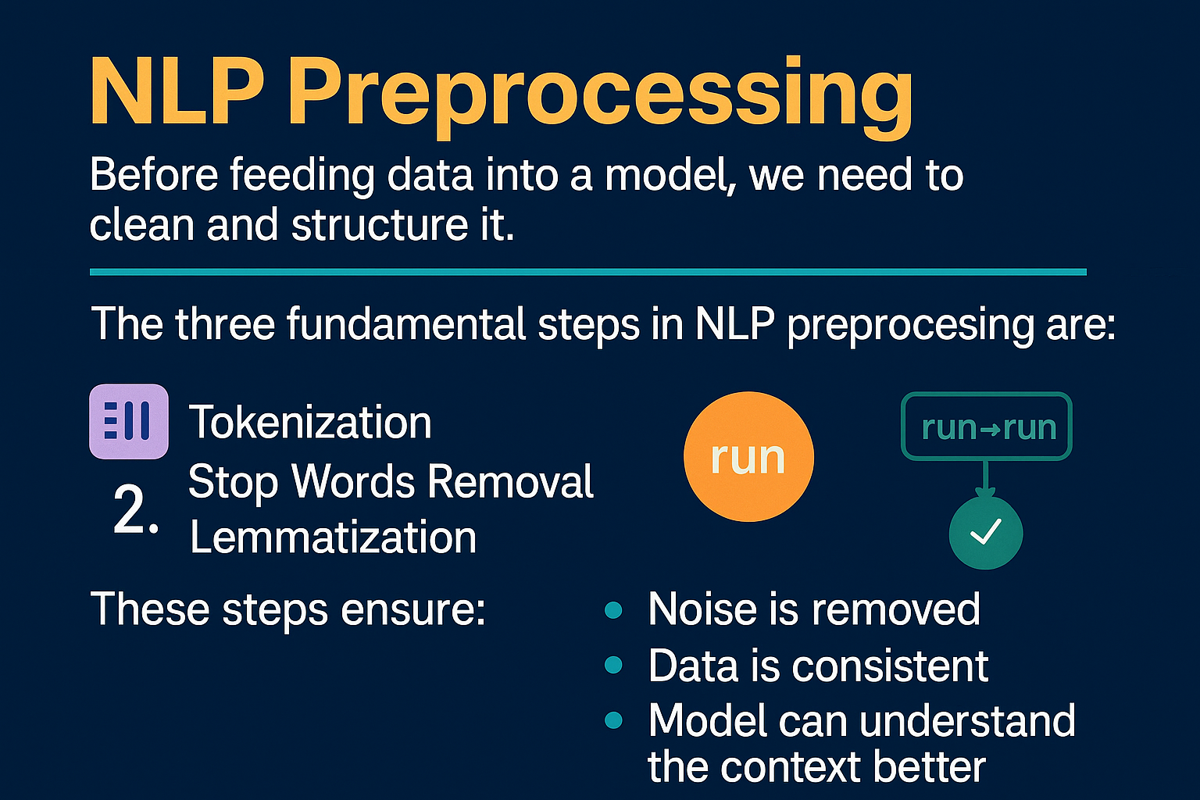

1. Tokenization
2. Stop Words Removal
3. Lemmatization

**These steps ensure**:

* Noise is removed
* Data is consistent
* Model can understand the context better

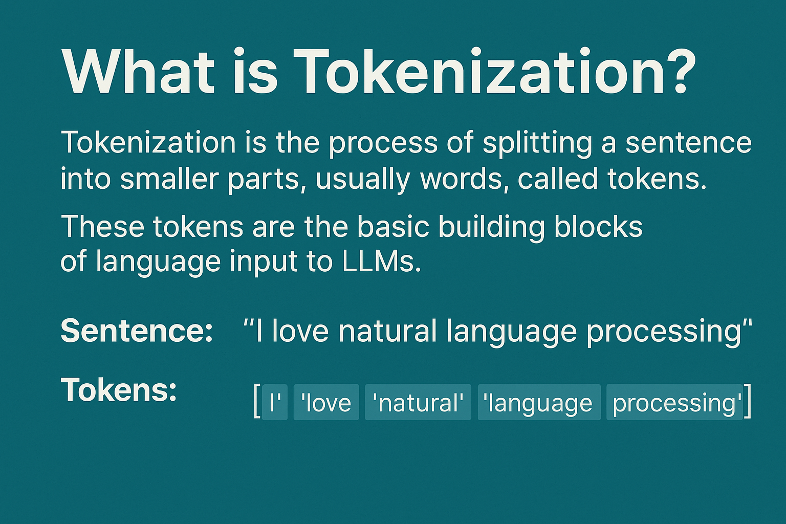

### 🧾 Example:

**Sentence**:  
"I love natural language processing"

**Tokens**:  
["I", "love", "natural", "language", "processing"]

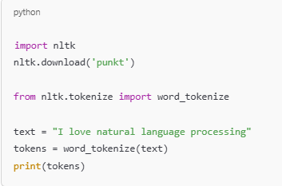

🧹 Stop Words Removal

🔍 **What are Stop Words?**

Stop Words are commonly used words in a language that usually do not contribute much meaning.

**Examples:**  
“is”, “am”, “the”, “in”, “on”, “a”, “of”, “to”, “and”

Removing them helps focus on the important words in a sentence.

**Example:**

Original Sentence:  
"I am learning NLP in Python"

After Removing Stop Words:  
["learning", "NLP", "Python"]

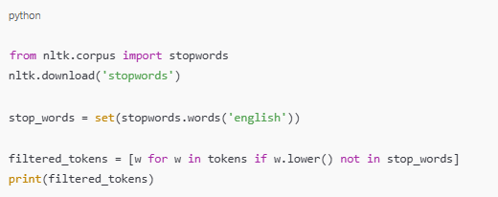

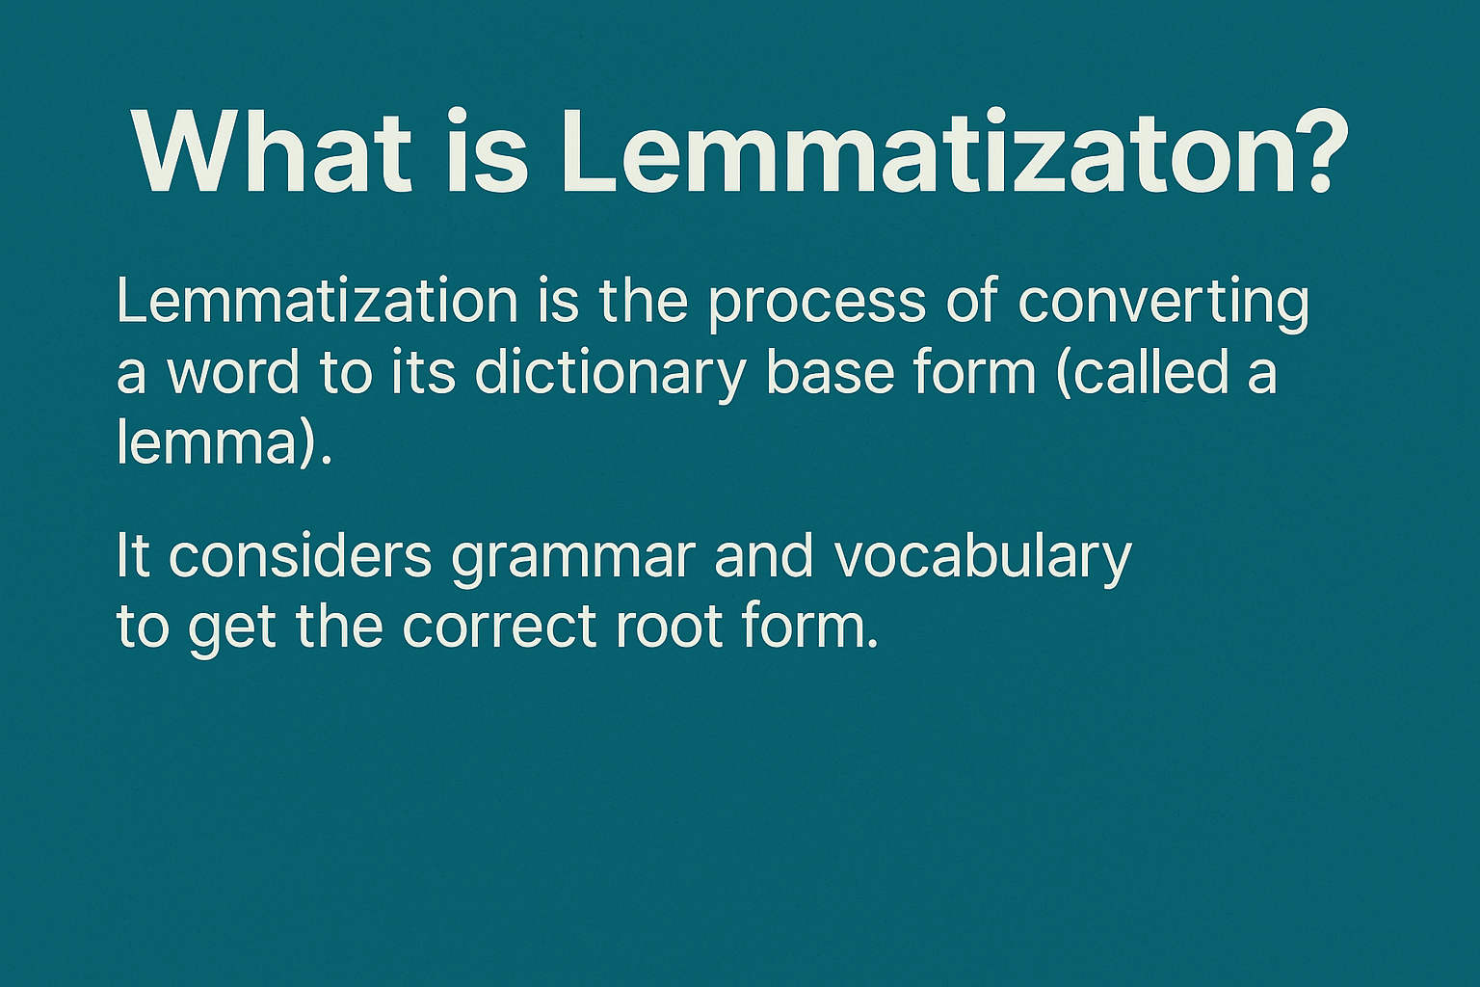

**Examples:**

* “running” → “run”
* “studies” → “study”
* “better” → “good”

Lemmatization helps in reducing variations of a word to one common form.

✅ **Summary**

We covered 3 important NLP preprocessing steps:

1. Tokenization  
   → Splits sentence into words
2. Stop Words Removal  
   → Removes common words that add less meaning
3. Lemmatization  
   → Converts words to base/dictionary form

These steps clean and simplify text, making it easier for Large Language Models (LLMs) to understand.

**Thank you**

Prashanth P